nClassrooms for Malawi Trustees Annual Report 2023 and Financial Statement



Contents

Our Strategy

A Letter from Our Chair

Trustees Annual Report

Independent Examiner’s Report

Accounts for the Year Ending September 2023

Legal and Administration



Our Strategy



Every child in Malawi will have access to a quality education in a safe and secure environment.



To provide a sustainable route out of poverty for the children of Malawi by creating a sustainable learning environment conducive to improved attendance, academic performance and aspiration – ultimately offering a sustainable route out of poverty.



Our guiding principle is that our work should be led by the expressed needs and aspirations of people and communities and the national priorities of Malawi. That work should be sustainable, innovative and be aware of and mitigate the impact on the environment.



To help children in Malawi find a sustainable route out of poverty through education.



* Build and renovate classrooms in Malawi.
* Raise targeted revenue to deliver our purpose.
* Support local initiatives that improve educational attainment and positively impacts on children in poverty.
* Develop effective partnerships in Malawi that deliver improved education outcomes.
* Raise our profile and leverage our good work to enable us to do more.

A Letter from Our Chair 

As we look back at last year, I can’t help thinking how much it mirrors our first year (2012). In a sense, last year was the first full year of our new beginnings after the impact we experienced during the Covid pandemic. Like many other charities, we emerged from the pandemic with a determination to build back better and I believe that we have been able to do that throughout this year.

When we began as a charity in 2012, we were starting from scratch. This time around we began with a solid base; we had a well-established and experienced Board, our long-standing Country Facilitator (Mr Dezie Trigu) and a clear and concise Strategic Plan. Although we were working with a much-restricted budget we were still able to improve the lives of children and teachers in Malawi. We started from a sound financial base along with a group of committed volunteers and partners who continued to support our work . Added to that we had a strong network of partners through the significant roles we played in Scotland and Malawi in supporting the work of the Scotland Malawi Partnership and the Malawi Scotland Partnership.

Beyond our control were the constant challenges faced by our friends in Malawi. In the last year alone, they experienced a widespread outbreak of Cholera as well as the devastating impact of Cyclone Freddy which affected over 2 million people and displaced over half a million with a death toll of over 1,000. Add to this, the challenging environment in which many of the Malawi communities have to work and provide an education for the children, only illustrates for me the continued need for Classrooms for Malawi’s support as our friends try to cope with so much on a daily basis.

As we began the year, it was clear that our capacity to raise funds, to deliver our work programme, was still fairly restricted. Similar in many ways to the two previous Covid impacted years. The serious cost of living crisis within the UK remains a significant factor in our ability to raise funds through individual giving and events. In addition, we found many grant sources were still restricted and we were one of many who were seeking funds in ever decreasing availability. However, I am pleased to say that we approached the difficult financial climate with the attitude of making a little go a long way and thankfully we were able to do that.

Thanks to our friends at Lancashire Rotary, we were able to offer training to 27 nursery volunteers, mostly young mothers, at 6 of the nurseries where we work. This Rotary group also funded much needed repairs to kitchens and classrooms in 4 nurseries badly damaged by Cyclone Freddy. They also paid for the delivery of soap, leaflets, buckets and basins to the 15 nurseries they support, to assist in the fight against Covid and Cholera.

In April, we rolled out the provision of sanitary kits at Ngumbe Community Day Secondary School. The kits are reusable and are expected to last for at least 3 years. This was paired with comprehensive menstrual and sexual health education to support the girls. The boys were educated through the “Men Who Know” programme. Teachers, the PTA members and Mothers’ Groups also learned about the programme and how to support the pupils. We are grateful for the support of our friends at Days for Girls during these presentations.

We worked closely with two groups, Hillpark Secondary and Kilsyth Boys Brigade, who visited Malawi in the summer of 2023. They visited their partner schools, Chilangoma Primary School and Katete Primary School. Between them they assisted in renovating 9 classrooms, provided library facilities as well as installing electricity in 12 classrooms. They engaged with the school committees in establishing ways to develop, long term mutual partnerships.

We also assisted in hosting visiting teachers from Princethorpe College on their visit to their partner school at Lauderdale Primary School. They will take a group of students to Malawi in 2024 and plan to visit and support work at Lauderdale Primary School and Makalanga Primary School.

We also received support from groups who were not travelling to Malawi.

* Dunblane Boys’ Brigade took part in sponsored fundraisers to repair the kitchen roof at Nansato PS.
* The Lindsay family ran events to fund 30 bunk beds and 60 mattresses at Ngumbe CDSS.
* Our own major fundraiser, the Afternoon Tea event was extremely well supported and allowed us to complete the build of the kitchen/community hub at Bright Future Nursery.
* Bannerman High School provided funding which will allow us to proceed in 2024 with a new 2 classroom block/library room at their partner school Masalani CDSS
* Celtic Foundation who are currently planning their group visit to Malawi in 2024 and will visit Masalani CDSS . They are providing the gap funding needed for the new 2 classroom block/library room at Masalani to be built in 2024.

We were very fortunate to receive support from a number of local schools and groups in Scotland who provided materials to support schools in Malawi. We are grateful to our friends at Bananabox Trust Dundee for transporting the materials to Malawi.

* St Anthony’s Primary School in Rutherglen funded pencils and notebooks for the pupils at Katete Primary School and Bright Future Nursery.
* Fernhill School, also in Rutherglen, provided science books for Ngumbe Community Day Secondary School.
* St Mary’s School in Melrose sent new school uniforms for the children at Emazinyeni PS.
* Kilsyth Boys Brigade provided 8 laptops for use in Katete Primary School
* Fix-it IT repair company in Motherwell provided 11 laptops for use in the 6 Secondary schools where we work.

In addition, we were grateful to our supporters who undertook a Kiltwalk, walked the Camino de Santiago de Compostela or ran a marathon to help raise funds for us.

On behalf of the Board, I would like to extend our sincere thanks to everyone who has supported us in any way this year and allowed us to complete many of the tasks we set out to achieve. I would also like to thank the many people who helped to keep our charity going during the last year. Our Board members, office volunteers, other volunteers and the many who have donated in various ways to support our work. I would also like to thank our colleague Dezie who works tirelessly in Malawi itself to ensure the projects and programmes are delivered.

To our friends in Malawi, in the various schools where we work, I am grateful for the cooperation and support you give to us. Also to the District and Divisional Education Managers with whom we work closely to coordinate our work with their school development plans. Without these close partnerships we would not be able to work in such close harmony with you and be able together to help improve the lives and conditions for the children , teachers and wider school communities where we have worked.

As we come to the end of our first “new” year I am grateful to report that we are still in a robust position as a charity and are ready to take on the increased workload we plan into 2024. In our own small way, we will continue to support and work alongside the communities in Malawi for the benefit of the children of Malawi to give them every opportunity to reach their full potential.

With best wishes and gratitude for all the support we receive.

James Kelly Chair

Classrooms for Malawi

26 September 2023

Trustees Annual Report

We look back at our achievements. Real progress has been made thanks to the hard work and dedication of our team in Malawi, our loyal supporters in the UK and the commitment of our office volunteers in Scotland.

# Projects Overview

A summary of our projects over the year are shown below, followed by some more details on each project.

| **Project** | **District** | **Partner** | **Work completed** |
| --- | --- | --- | --- |
| Carers’ Training ECDCs | Blantyre Rural | Rotary Lancashire  Phase 4 | 2-week training course |
| Handwashing support | All Areas | Donations  Appeal | Soap distribution |
| Ngumbe CDSS | Blantyre Rural | Donations  Appeal | Sanitary products and training |
| Chilangoma PS | Blantyre Rural | Hillpark Secondary School | 2 classrooms /library room renovations. |
| Nansato PS | Shire Highlands | Dunblane BBs | Roof of Mary's Meals block and latrines repair |
| Katete PS | Blantyre Rural | Kilsyth BBs | 9 classrooms renovated |
| 15 Nurseries | Various | Rotary Lancashire  Phase 5 | WASH programme and renovations |
| Ngumbe CDSS | Blantyre Rural | Lindsay Family | 30 bunk beds and 60 mattresses |
| Bright Future | Blantyre Rural | Classrooms for Malawi | Kitchen/Community Hub completion |

Carers’ Training at ECDCs

With funding from the Rotary Foundation, District 1190 (Kirkham & Rural Fylde, Lunesdale, Workington Derwent and Furness Peninsula), the Association of Early Childhood Development in Malawi (AECDM) conducted a two-week Early Childhood Basic training for 27 participants. The participants were drawn from the following nursery schools: Mzedi Butao (5), Kachere (1), Madulira (2), Mang’omba (3), Mbinda (5), Mpunga (3), St Mary’s Chemusa (3), Bright Future (4) and Joshua Foundation (1).

The overall objective of the training was to provide the 27 caregivers with adequate theoretical and practical skills to plan developmentally appropriate activities that will enhance children’s development in their nursery schools. Participants also managed to develop quality learning and play materials.

Pre- and post- test analysis revealed that there was a great change in knowledge because of the training.

Handwashing Support

Following the cholera outbreak in Malawi in 2022, CfM launched an appeal to be able to distribute soap for handwashing to every school where CfM have worked since 2012. The purpose was to improve hygiene and help prevent the spread of the disease.

There are currently a total of 50 schools and nurseries across Malawi (35 primary and secondary schools and 15 nursery schools) where CfM has worked. The plan was to provide every location with three cartons of soap with 30 bars of soap in each carton. A total of 4500 bars of soap for over 37,000 pupils: this would be sufficient to support hand washing at a school for three months.

The mutual beneficial friendship and collaboration with sister charity Mary’s Meals was a substantial help in reaching the more outlying and inaccessible locations.

Ngumbe CDSS Menstrual Education and Kit Distribution

CfM and Mangoplus Days for Girls provided training on menstrual health and reproductive biology to boys and girls at Ngumbe. In addition, 384 form 1 and 2 students were received sanitary kits which comprised: 2x shields, 6x liners, 2x pants, 1 x tablet soap,1x carry pouch and 1x drawstring bag. One kit will last for a period of 4 years.

Chilangoma PS

This year, CfM has renovated one block of two classrooms, repainted the 2015/16 CfM classroom block and rehabilitated the mini library.

Nansato PS

We are delighted to announce that thanks to our builders and the support of the 25th Stirling (Dunblane) Boys Brigade, we have been able to finish the renovation of a Mary’s Meals kitchen at Nansato Primary.

Katete PS

This report follows the making of 30 bunk beds and the provision of 60 mattresses at Ngumbe CDSS. The funds were provided by the Lindsay family and followed their visit to the school in Nov 2022 where they saw the poor condition of the boys’ dormitories.

Wash Programme for 15 Nurseries

With funding from The Rotary International District 1190, CfM provided each of the 15 nursery schools with: 2 water tap buckets, 2 basins and 90 bars of soap.

The second component of this phase comprised the renovation of Pit latrines, classrooms and kitchen repair in four nursery schools.

Ngumbe CDSS

This project provided 30 bunk beds and 60 mattresses to Ngumbe CDSS. The funds were provided by the Lindsay family and followed their visit to the school in 2022 where they saw the poor condition of the boys’ dormitories.

Bright Future

After a 2-classroom block was built by CfM in 2017, the community worked to build and complete a multi-purpose building to facilitate storing food and cooking meals for the children as well as a preparation room for the caregivers. Unfortunately, money and resources ran out and despite ongoing efforts it is still unfinished. CfM helped complete the kitchen and community room.

# Fundraising

Fundraising provides the financial resources to carry out our mission and we are very grateful to all who supported our fundraising activities throughout the year. These included a Comedy Night and an Afternoon Tea. During this time, we also promoted an Autumn Raffle as well as one at Christmas and are pleased to say that our weekly lottery continues to grow.

As always, we are thankful to all our walkers and runners and all those who donate on a regular basis.

# Our Governance

In 2023 we said goodbye to Kerry Lindsay and Aurelie Walker-Dean

We are pleased to welcome new UK board members, Maureen Casey and Julie Minal and from Malawi, Precious Mbale and Lucky Katundu.

# Reserves Policy

As a dynamic organisation relying almost entirely on individual giving, we need to hold adequate reserves so that we can react to challenging economic times and unexpected opportunities in Malawi.

The Trustees consider it prudent for Classrooms for Malawi SCIO to maintain operational unrestricted reserves (defined as unrestricted net current assets) so that in the event of a substantial reduction in income, then UK office expenditure may be covered for a period of at least 3 months. The Trustees are confident that this policy is currently being met.

It is our aim to grow our reserves substantially in the next three to five years as will be required from the year-on-year growth that Classrooms for Malawi SCIO has experienced since its inception. At the same time, we always aim to maximise the money we can spend now to provide a sustainable route out of poverty.

# Investment Policy

The Charity’s cash reserves are very modest and in view of the importance of having immediate access to liquid working capital, we utilise an interest-bearing current account. In view of the modest level of reserves, the Trustees take a very conservative view on investing liquid assets outside of the established banking system.

# Ethical Policy

The Trustees have a duty under charity law to maximise Classrooms for Malawi's income and thereby maximise expenditure on our charitable objectives. However, it is essential we do not allow any third party to bring our name into disrepute. We have an ethics policy which makes sure ethical considerations are considered when deliberating opportunities, for example when deciding whether to accept or refuse a donation or participate in partnerships with other organisations.

# Environmental Policy

We recognise we have a responsibility to minimise our impact on the planet and use resources wisely. We are currently developing a corporate social responsibility policy, which, when ready, will incorporate an environmental policy and help to embed green initiatives across Classrooms for Malawi SCIO in a more consistent and accountable way.

# Going Concern

The Trustees have reviewed the Charity's financial position. As a result of its review, the Trustees believe that the Charity is well placed to manage operational and financial risks successfully.

Accordingly, Classrooms for Malawi SCIO has a reasonable expectation that the Charity has adequate resources to continue in operational existence for the foreseeable future. Thus, Classrooms for Malawi SCIO continues to adopt the going concern basis of accounting in preparing the annual accounts.

# Structure, Governance and Management

## Governing Document

The charity is controlled by its Constitution, a deed of trust, and constitutes an incorporated charity.

Classrooms for Malawi SCIO operates as a registered charitable incorporated organisation with the Office of Scottish Charity Regulator (OSCR) and does not consist of subsidiaries or other connected organisations.

## Board of Trustees

The governing body of Classrooms for Malawi is a Board of Trustees. Trustees serve an initial term of three years and are eligible for reappointment.

The Board’s principal responsibilities include determining and implementing the overall strategy, policies, direction and goals of Classroom for Malawi SCIO; protecting and promoting the identity and values of the charity; and fulfilling out statutory responsibilities. Where necessary, the Board delegates certain functions to employees, contractors and volunteers.

## Trustees’ Responsibilities

The law applicable to charities in Scotland requires the Trustees to prepare financial statements for each financial year which give a true and fair view of the charity and of the incoming resources and application of resources of the charity for that period. In preparing these financial statements, the Trustees are required to:

* select suitable accounting policies and then apply them consistently;
* observe the methods and principles in the Charities SORP;
* make judgements and estimates that are reasonable and prudent;
* state whether applicable accounting standards have been followed; and
* prepare the financial statements on the going concern basis unless it is inappropriate to presume that the charity will continue in business.

The charity's trustees are responsible for the preparation of the accounts in accordance with the terms of the Charities and Trustee Investment (Scotland) Act 2005 and the Charities Accounts (Scotland) Regulations 2006 (as amended). The charity's trustees consider that the audit requirement of Regulation 10(1)(a) to (c) of the Accounts Regulations does not apply. They are also responsible for safeguarding the assets of the charity and hence for taking reasonable steps to prevent and detect fraud and other irregularities.

Financial statements are published on the organisation’s website (classroomsformalawi.org) in accordance with legislation in the UK governing the preparation and dissemination of financial statements, which may vary from legislation in other jurisdictions. The Trustees’ responsibilities also extend to the ongoing integrity of the financial statements.

## Recruitment and Appointment of New Trustees

When recruiting new Trustees, the Board gives regard to the skills, knowledge and experience required for the effective administration and direction of the SCIO with a particular focus on financial management, international development, compliance, income generation and communications. We regularly review the skills, expertise and contribution of our Trustees to identify gaps and development needs.

Classrooms for Malawi SCIO operates an equal opportunities and diversity policy and encourages applications from diverse backgrounds to reflect the nature of our work and our primary beneficiaries. Trustees are appointed following open promotion of vacancies. Interviews are conducted by the Chair and CEO, with input from other Trustees as required. New Trustees are required to sign the Trustee Handbook containing a declaration of interests, anti-bribery policy, fit and proper person’s declaration, and our Code of Conduct and Safeguarding policy.

All new Trustees receive a structured induction programme that covers all aspects of the role, and an overview of the organisation. Trustees receive a comprehensive induction pack prior to commencement.

## Key Management Remuneration

The charity is managed by its Trustees, who work on a voluntary basis and receive no salary or remuneration.

Classrooms for Malawi only has one paid member of staff. Salaries are reviewed annually by the Board of Trustees who decide on the level of remuneration to be awarded.

## Gender Pay Reporting

During the year ended 30 September 2019, Classrooms for Malawi SCIO employed one full- time member of staff and is a proud supporter of the Living Wage. As such, there is no disparity between gender pay within our organisation.

# Risks

## Principal Risks and Uncertainties

Responding to the educational needs of the children of Malawi involves financial and operational risk taking. Classrooms for Malawi takes risk management very seriously and has a clear organisational policy and associated framework and procedures in place to ensure risks are anticipated and mitigated effectively and consistently.

From a financial perspective, the Charity manages its risk by keeping a prudent level of reserves in place and ensuring that expenditure is always matched by income. This is monitored very closely, and projects are not started unless there is every reasonable expectation that money will be in place throughout the lifespan of the project. Our cash reserves are held with reputable banks and controls are in place to reduce the possibility of theft or fraud.

Health and safety are of paramount concern. Whilst in the UK this risk is easily managed, the nature of the work we undertake in Malawi by our employees, volunteers and visitors means that our policies and safeguards are more challenging to implement. We continue to follow a risk assessment framework with a constant focus on monitoring this area annually in a bid to improve our processes.

## Risk Framework and Controls

Our wider assurance framework includes our in-depth policies on risks, incident reporting, anti-fraud, bribery and corruption, management of complaints and grievances, safeguarding and raising concerns (whistleblowing). These policies ensure that, where incidents give rise to risks, these are identified, acted on swiftly and reported according to our regulatory responsibilities.

## Roles and Responsibilities

Our Board of Trustees is responsible for ensuring that Classrooms for Malawi has robust and effective risk management processes and assurance functions in place.

# Safeguarding and Code of Conduct

Classrooms for Malawi works to uphold the fundamental rights of all children – and we are committed to keeping children safe from harm and abuse. Children and young people are at the centre of everything we do.

We take our responsibility to safeguard all people who come into contact with Classrooms for Malawi, including our own staff and volunteers, extremely seriously.

Classrooms for Malawi has a zero-tolerance approach to child abuse. Non-compliance with our child safeguarding policy is subject to disciplinary action, including dismissal.

As an organisation with both a UK and an international purpose, Classrooms for Malawi will not tolerate any sexual harassment or misconduct. We are committed to promoting an organisational culture in which all staff and volunteers feel safe to speak up and we address all cases of sexual harassment and misconduct in line with our policies and commitments.

Moving forward, we will have a comprehensive range of checks in place to safeguard staff, volunteers and the people we help. Our safeguarding policies can be found on our website.

Our policies clearly state that all safeguarding concerns are logged, investigated and escalated as appropriate.

Our practice is to report incidents to the relevant authorities at the time these occur, including to OSCR. This includes referrals made to the police and other statutory authorities. To date, we have received no such reports and no referrals have been made.

Our safeguarding procedures have been reviewed and updated in the past 12 months.

# Charities (Protection and Social Investment) Act 2016 Statement

The charity is not required to report under this Act, as Classrooms for Malawi is a Scottish Charitable Incorporated Organisation. We do so for the sake of readers of these accounts from England and Wales, and since we believe this represents best practice with regard to disclosing our approach to fundraising, since this is such a significant source of income.

## Fundraising Approach

We rely on a number of different fundraising approaches in order to raise funds cost-effectively from a range of sources, raising awareness of our work and allowing supporters to contribute in ways that are most appropriate for them. This includes fundraising face-to-face; through letters, emails, and online; from events and community fundraising; from philanthropists, trusts, foundations and corporate partners.

## Fundraising on our Behalf

We engage supporters of Classrooms for Malawi to be advocates of the charity, and to speak to potential supporters. As a result of these conversations, many are inspired to start a regular gift, generating significant income that we direct to providing a suitable learning environment for the children of Malawi.

Whilst we encourage fundraisers to act on our behalf and operate with the integrity and accountability that a charity such as Classrooms for Malawi deserves, we are not responsible for any actions that may bring the Charity’s name into disrepute. To this end, we ask that all fundraisers act in a transparent manner and seek advice from official personnel when required.

## Monitoring of Fundraising Activities and Protecting People in Vulnerable Circumstances

We have policies in place, endorsed by our Board of Trustees which govern our fundraising activities, whether they are carried out internally or through our funders. We have a comprehensive quality control framework in place to monitor the behaviour our fundraisers, as well as the conversations they have on our behalf with both supporters and members of the public. This includes the monitoring of outcomes, complaints and remedial actions. Our aim is to ensure that potential supporters feel informed, genuinely thanked and inspired by their conversation, regardless of its outcome.

We are committed to ensuring that we always treat the public sensitively and respectfully, taking special care to protect people who may find themselves in vulnerable circumstances. Our fundraising policy, signed by all Classrooms for Malawi volunteers, contains a section dedicated to making fundraisers aware of the signs of potential vulnerability in anyone they speak to on our behalf, as well as the steps we expect them to take on the rare occasions when they do have concerns.

This approach has been developed in consultation with safeguarding staff and is in line with the requirements of the Charities (Protection and Social Investment) Act 2016, as well as with the IOF’s Treating Donors Fairly Guidance, and the Direct Marketing Association’s Guidelines for Dealing with Vulnerable Consumers.

## Complaints

We have a robust and well-established complaints procedure. During the last financial year, we received no complaints from members of the public about our fundraising activities.

# Independent Examiner’s Report to the Trustees of Classrooms for Malawi

I report on the accounts for the year ended 30 September 2022 set out on pages fifteen to twenty eight.

## Respective Responsibilities of Trustees and Examiner

The charity's Trustees are responsible for the preparation of the accounts in accordance with the terms of the Charities and Trustee lnvestment (Scotland) Act 2005 and the Charities Accounts (Scotland) Regulations 2006. The charity's trustees consider that the audit requirement of Regulation 10(l)(a) to (c) of the Accounts Regulatlons does not apply. It ls my responsibility to examine the accounts as required under Section 44(1)(c) of the Act and to state whether particular matters have come to my attention.

Basis of the independent examiner’s report

My examination was carried out in accordance with Regulation 11 of the Charities Accounts (Scotland) Regulations 2006. An examination includes a review of the accounting records kept by the charity and a comparison of the accounts presented with those records. It also includes consideration of any unusual items or disclosures in the accounts and seeking explanations from you as Trustees concerning any such matters. The procedures undertaken do not provide all the evidence that would be required in an audit, and consequently I do not express an audit opinion on the view given by the accounts.

**Independent** examiner's statement

In connection with my examination, no matter has come to my attention:

which gives me reasonable cause to believe that, in any material respect, the requirements

— to keep accounting records in accordance with Section 44(1)(a) of the 2005 Act and Regulation 4 of the 2006 Accounts Regulations; and to prepare accounts which accord with the accounting records and to comply with Regulation 8 of the 2006 Accounts Regulations have not been met; or

to which, in my opinion, attention should be drawn in order to enable a proper understanding of the accounts to be reached.

David Nicholls FCCA

Fellow, Association of Chartered Certified Accountants

Brett Nicholls Associates

# Accounts for the Year Ending September 2023

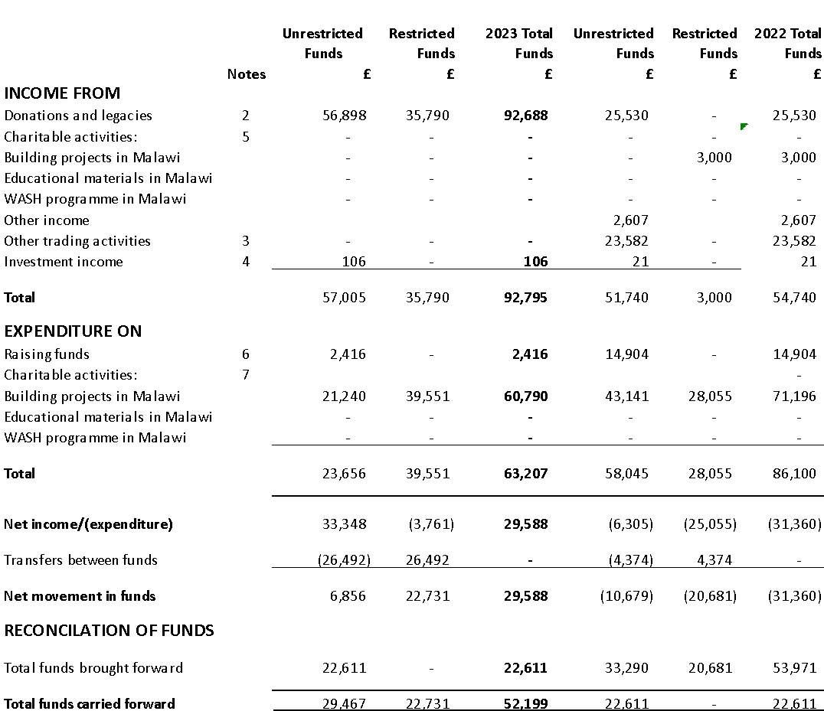

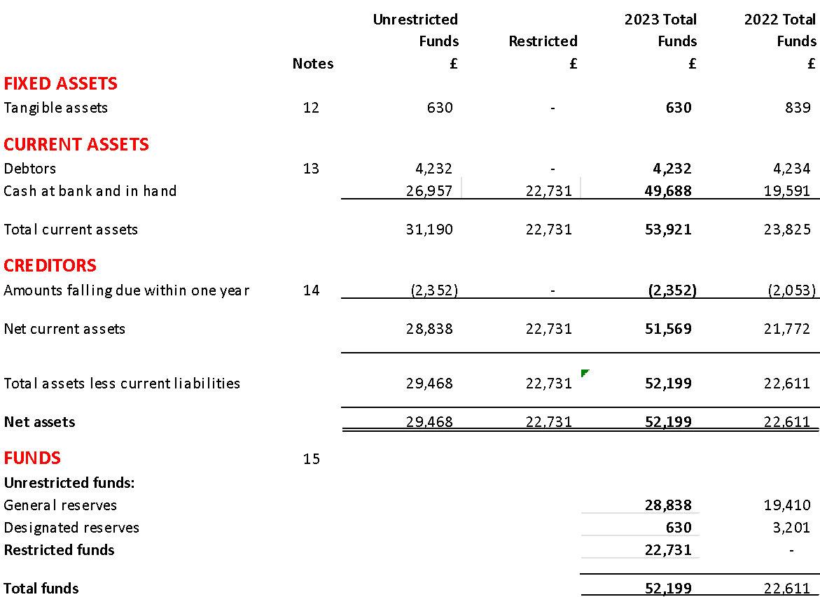

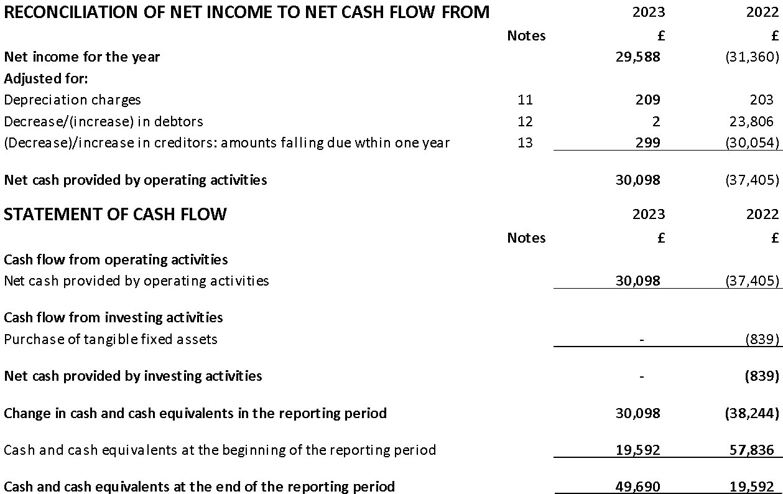

The notes below form part of the Financial Statements.

CLASSROOMS FOR MALAWI

ACCOUNTS TO 30 SEPTEMBER 2023

NOTES TO THE ACCOUNTS

1. ACCOUNTING POLICIES

a) Scope and basis for the financial statements

The financial statements have been prepared under the historical cost convention, and are in accordance with the Statement of Recommended Practice: Accounting and Reporting by Charities preparing their accounts in accordance with the Financial Reporting Standard applicable in the UK and republic of Ireland (FRS 102) (the SORP), FRS 102: The Financial Reporting Standard applicable in the UK and Republic of Ireland (FRS 102), the Charities and Trustee Investment (Scotland) Act 2005 and UK Generally Accepted Accounting Practice. 2020 £ (33,993) 2020 £ (22,350) (1,018) (1,018) (35,011) 57,835 (22,350) 80,185 22,825 57,835 Classrooms for Malawi– trustees’ annual report and financial statement The functional currency of Classrooms for Malawi SCIO is GBP because that is the currency of the primary economic environment in which the organization operates. After reviewing the charity’s forecast and projections, the trustees have a reasonable expectation that the charity has adequate resources to continue in operational existence for the foreseeable future. The charity therefore continues to adopt the going concern basis of preparation of the financial statements as discussed in the Trustees’ Report at page 16. Classrooms for Malawi SCIO constitutes a public benefit entity as defined by FRS 102. In the application of the charity’s accounting policies, which are descried in this note, trustees are required to make judgements, estimates and assumptions that affect the application of polices and reported amounts in the financial statements. The areas involving a higher degree of judgement, or areas where assumptions or estimates were significant to the financial statements are described at (j) below.

b) Fund Accounting

General funds are unrestricted funds that are available for use at the discretion of the Trustees in furtherance of the general charitable objectives, and that have not been designated for other purposes. Designated funds comprise unrestricted funds that have been set aside for a particular purpose by the Trustees. Restricted funds are funds that are to be used in accordance with specific restrictions imposed by donors or that have been raised by the charity for a particular purpose. Such donations are principally for international building and renovation purposes. Costs are charged against the specific fund in line with donor wishes. Further explanation of the nature and purpose of each fund is included in the notes to the financial statements.

c) Incoming resources

All income is accounted for when Classrooms for Malawi SCIO has entitlement to the funds, the amount can be quantified, and receipt of the funds is probable. Where income is received in advance of providing goods and/or services, it is deferred until Classrooms for Malawi SCIO becomes entitled to that income. Donations include all income received by the charity that is made on a voluntary basis and is not conditional on delivery of certain levels or volumes of service or supply of charitable goods. This will Classrooms for Malawi– trustees’ annual report and financial statement include grants from institutions, corporates and major donors that provide core funding, or are of a general nature. Gifts for onward distribution are included at fair value and are recognized as income and stock when they are received from donors and in expenditure when they are distributed to beneficiaries. Gifts in kind include educational materials. Our volunteers play a vital role in the activities of the charity, including as community fundraisers and ambassadors. However, in accordance with the SORP, no monetary value has been attributed to their contribution and been included in these accounts. Grants from agencies and foundations, corporates and trusts have been included as ‘Income from charitable activities’ where these grants specifically outline the goods and services to be provided to beneficiaries. For these performance related grants, in the absence of specific milestones to determine entitlement, income is recognized to the extent that resources have been committed to the specific programme, as this is deemed to be a reliable estimate of the right to receive payment for the work performed. In this case, cash received in excess of expenditure is included as a creditor (as deferred income) and expenditure in excess of cash included as a debtor (as accrued income). All restricted project funds are held in separate bank accounts, and any interest income arising on such funds held is treated as unrestricted to offset international bank charges.

d) Resources expended and basis of allocation of cost

All expenditure is accounted for on an accrual basis and has been classified under headings that aggregate all costs related to the category. Expenditure on raising funds is that incurred in seeking voluntary income and does not include the costs of disseminating information in support of the charitable activities. Expenditure on charitable activities are costs incurred directly and specifically in the furtherance of Classrooms for Malawi’s charitable objectives, along with associated support costs. Support costs are those which provide indirect support to front-line output provision; examples include, but are not limited to, staff and governance costs. Support costs not attributable to single activity have been allocated on basis consistent with identified cost drivers for that cost category such as staff time and expenditure. Classrooms for Malawi– trustees’ annual report and financial statement

e) Tangible fixed assets and depreciation

All expenditure of a capital nature on project development overseas is expensed as incurred, as are tangible items of expenditure in the UK more than £100. Depreciation is provided from the time assets are available for use at rates calculated to write off the costs on a straight-line basis over their useful economic lives as follows: − Computer equipment and software – 4 years.

f) Financial instruments

Financial assets and financial liabilities are recognized when Classrooms for Malawi SCIO becomes a party to the contractual provisions of the instrument. All financial assets and liabilities are initially measured at transaction price (including transaction costs). Classrooms for Malawi SCIO only has financial assets and financial liabilities of a kind that qualify as basic financial instruments. Basic financial instruments are initially recognized at transaction value and subsequently measure at their settlement value. Trade and other debtors are recognized at the settlement amount due after any trade discount offered. Prepayments are valued at the amount prepaid net of any trade discounts due. Creditors and provisions are recognized where Classrooms for Malawi SCIO has a present obligation resulting from a past event that will probably result in the transfer of funds to a third party and the amount due to settle the obligation can be measured or estimated reliably. Creditors and provisions are normally recognized at their settlement amount after allowing for any trade discounts due.

g) Provisions

Provisions for liabilities are recognized when Classrooms for Malawi SCIO has a legal or constructive financial obligation, for which a measurable future outflow of funds is probable.

h) Foreign currencies

Monetary assets and liabilities are translated into sterling at the exchange rate ruling on the balance sheet date. Foreign exchange gains are recognized as other income and foreign exchange losses are recognized in the consolidated statement of financial activities within the relevant charitable activity expenditure for the period in which they are incurred.

i)Taxation Classrooms for Malawi

SCIO is a registered charity and is thus exempt from tax on its charitable activities. The charity also falls Classrooms for Malawi– trustees’ annual report and financial statement below the VAT registration threshold for income from taxable supplies and is therefore not registered for VAT.

j) Accounting estimates and judgments

In the application of the charity’s accounting policies described above, the Trustees are required to make estimates, judgements and assumptions about the carrying amounts of assets and liabilities that are not readily apparent from other sources. These estimates, judgements and assumptions are made based on a combination of past experience, professional expert advice, and other evidence that is relevant to the particular circumstance. The following areas are considered to involve the critical judgements and sources of estimation uncertainty when applying the charity’s accounting policies:

Cost allocation Costs not attributable to a single activity are allocated or apportioned to activities on a basis consistent with identified cost drivers for that cost category. This methodology requires a judgement as to what are the most appropriate bases to use to apportion support costs; these are reviewed annually for reasonableness.

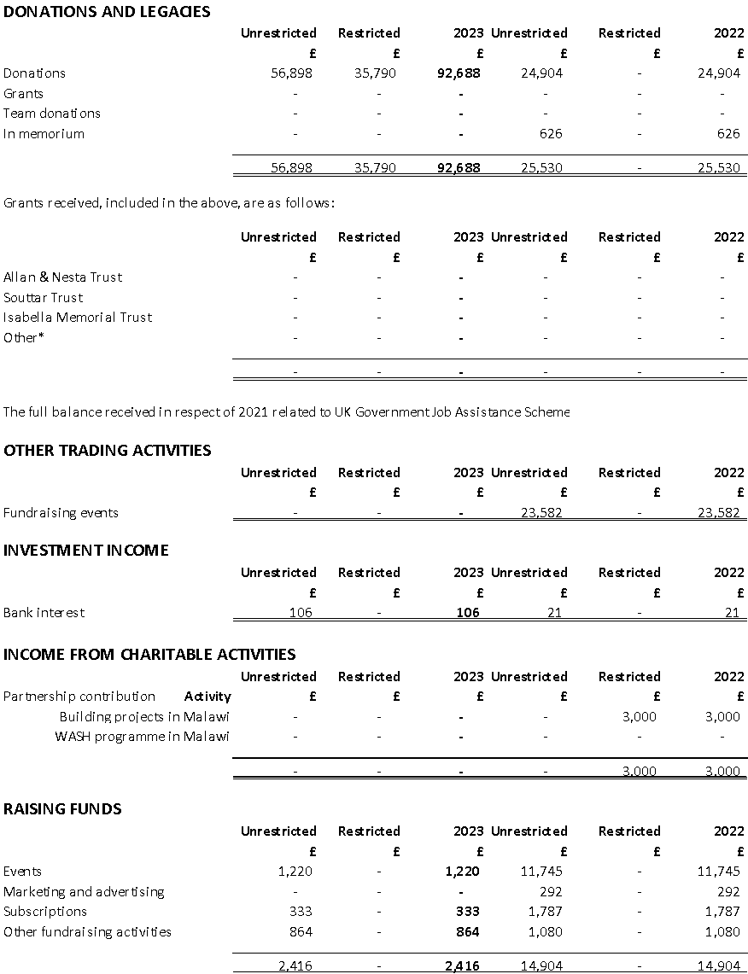

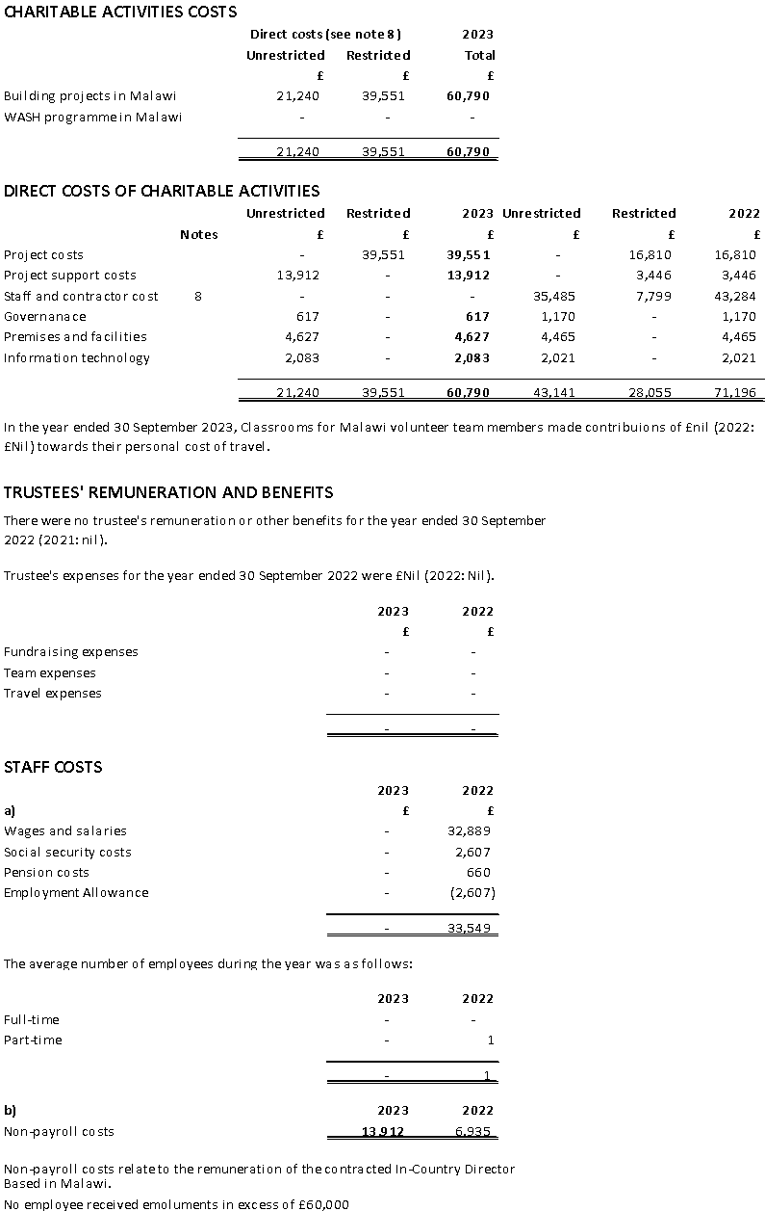

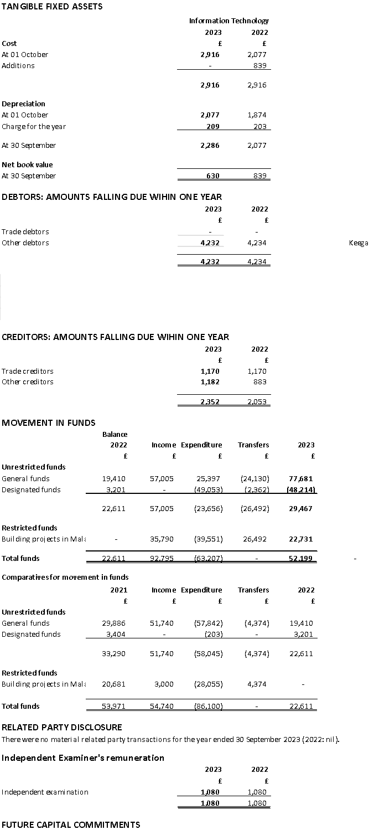

# Legal and Administration

Board of Trustees

James Kelly (Chair)

David Morley (Vice Chair)

Michael Cunningham (Treasurer) first elected 22 September 2022

Patricia Duffy (Secretary)

Precious Mbale

Lucky Katundu

Maureen Casey

Julie Minal

Registered Office and Principal Address

2 Kirkwood Street, Rutherglen, Scotland

G73 2SL

Contact Details

Telephone: 0141 571 8505

Email: info@classroomsformalawi.org

Website: www.classroomsformalawi.org

Registered Charity Number

SC048091

Independent Examiner

Brett Nicholls Associates

63 Ruthven Lane Glasgow

G12 9BG

Bankers

Barclays Plc.

12 Churchill Place Canary Wharf London

EH 14 5HP

Thank You

A huge thank you to our volunteers and supporters who dedicate their time, energy and resources to the advancement of Classrooms for Malawi’s cause - that every child in Malawi has access to a suitable learning environment.